Supplementary Information S1. CA-TIMS U-Pb Geochronology Methods and Results
U-Pb dates were obtained by the chemical abrasion isotope dilution thermal ionization mass spectrometry (CA-TIMS) method from analyses composed of single zircon grains (Table 1), modified after Mattinson (2005). Zircon was removed from an epoxy mount and placed in a muffle furnace at 900°C for 60 hours in quartz beakers. Zircon was removed from the epoxy mounts for dating based on LA-ICPMS data that were collected at UCSB.
Zircon was put into 3 ml Teflon PFA beakers and loaded into 300 μl Teflon PFA microcapsules. Fifteen microcapsules were placed in a large-capacity Parr vessel and the zircon partially dissolved in 120 μl of 29 M HF for 12 hours at 190°C. Zircon was returned to 3 ml Teflon PFA beakers, HF was removed, and zircon was immersed in 3.5 M HNO₃, ultrasonically cleaned for an hour, and fluxed on a hotplate at 80°C for an hour. The HNO₃ was removed and zircon was rinsed twice in ultrapure H₂O before being reloaded into the 300 μl Teflon PFA microcapsules (rinsed and fluxed in 6 M HCl during sonication and washing of the zircon) and spiked with the EARTHTIME mixed ²³³U-²³⁵U-²⁰⁵Pb tracer solution (ET535). Zircon was dissolved in Parr vessels in 120 μl of 29 M HF with a trace of 3.5 M HNO₃ at 220°C for 48 hours, dried to fluorides, and re-dissolved in 6 M HCl at 180°C overnight. U and Pb were separated from the zircon matrix using an HCl-based anion-exchange chromatographic procedure (Krogh, 1973), eluted together and dried with 2 µl of 0.05 N H₃PO₄.
Pb and U were loaded on a single outgassed Re filament in 5 µl of a silica-gel/phosphoric acid mixture (Gerstenberger and Haase, 1997), and U and Pb isotopic measurements made on a GV Isoprobe-T multicollector thermal ionization mass spectrometer equipped with an ion-counting Daly detector. Pb isotopes were measured by peak-jumping all isotopes on the Daly detector for 160 cycles, and corrected for 0.16 ± 0.03%/a.m.u. (1σ) mass fractionation. Transitory isobaric interferences due to high-molecular weight organics, particularly on ²⁰⁴Pb and ²⁰⁷Pb, disappeared within approximately 30 cycles, while ionization efficiency averaged 10⁴ cps/pg of each Pb isotope. Linearity (to ≥1.4 x 10⁶ cps) and the associated deadtime correction of the Daly detector were determined by analysis of NBS982. Uranium was analyzed as UO₂⁺ ions in static Faraday mode on 10¹² ohm resistors for 300 cycles, and corrected for isobaric interference of ²³³U¹⁸O¹⁶O on ²³⁵U¹⁶O¹⁶O with an ¹⁸O/¹⁶O of 0.00206. Ionization efficiency averaged 20 mV/ng of each U isotope. U mass fractionation was corrected using the known ²³³U/²³⁵U ratio of the ET535 tracer solution.
CA-TIMS U-Pb dates and uncertainties were calculated using the algorithms of Schmitz and Schoene (2007), ET535 tracer solution (Condon et al., 2015) with calibration of ²³⁵U/²⁰⁵Pb = 100.233, ²³³U/²³⁵U = 0.99506, and ²⁰⁵Pb/²⁰⁴Pb = 11268, and U decay constants recommended by Jaffey et al. (1971) and ²³⁸U/²³⁵U of 137.818 (Hiess et al., 2012). ²⁰⁶Pb/²³⁸U ratios and dates were corrected for initial ²³⁰Th disequilibrium using D_{Th/U} = 0.2 ± 0.1 (2σ) and the algorithms of Crowley et al. (2007), resulting in an increase in the ²⁰⁶Pb/²³⁸U dates of ~0.09 Ma. All common Pb in analyses was attributed to laboratory blank and subtracted based on the measured laboratory Pb isotopic composition and associated uncertainty. U blanks are estimated at 0.013 pg.
Weighted mean ²⁰⁶Pb/²³⁸U dates are calculated from equivalent dates (probability of fit >0.05) using Isoplot 3.0 (Ludwig, 2003). Errors on weighted mean dates are given as ± x / y / z, where x is the internal error based on analytical uncertainties only, including counting statistics, subtraction of tracer solution, and blank and initial common Pb subtraction, y includes the tracer calibration uncertainty propagated in quadrature, and z includes the ²³⁸U decay constant uncertainty propagated in quadrature. Internal errors should be considered when comparing our dates with ²⁰⁶Pb/²³⁸U dates from other laboratories that used the same tracer solution or a tracer solution that was cross-calibrated using EARTHTIME gravimetric standards. Errors including the uncertainty in the tracer calibration should be considered when comparing our dates with those derived from other geochronological methods using the U-Pb decay scheme (e.g., laser ablation ICPMS). Errors including uncertainties in the tracer calibration and ²³⁸U decay constant (Jaffey et al., 1971) should be considered when comparing our dates with those derived from other decay schemes (e.g., ⁴⁰Ar/³⁹Ar, ¹⁸⁷Re-¹⁸⁷Os). Errors are at 2σ.

U-Pb Geochronology Results
Seven grains were analysed by CA-TIMS. The youngest four dates yield a weighted mean of 56.83 ± 0.04 / 0.04 / 0.08 Ma (Mean Squared Weighted Deviation = 1.2, probability of fit = 0.30). This is interpreted as the maximum depositional age. Other dates are 57.39 ± 0.06, 57.39 ± 0.14, and 57.24 ± 0.06 Ma.

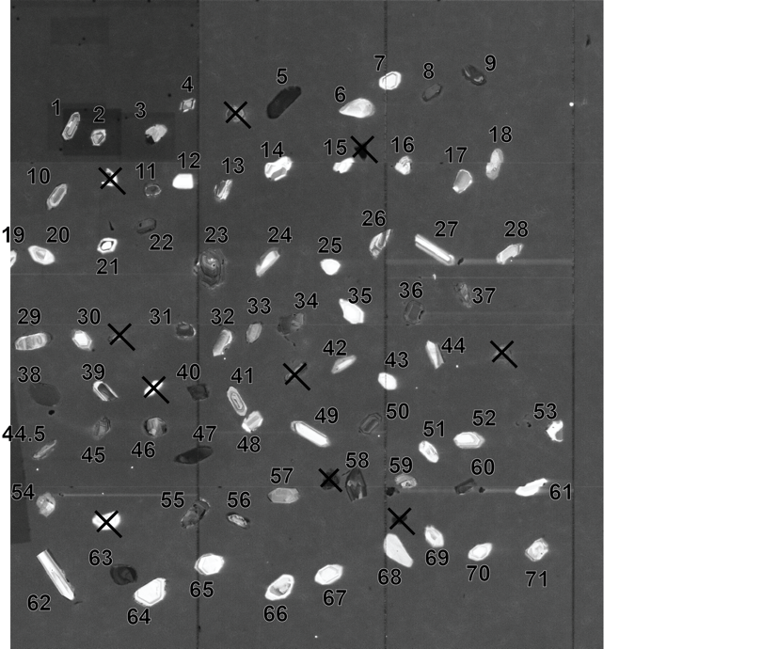
UR-EAC-03 sample zircons analyzed under cathodoluminescence.

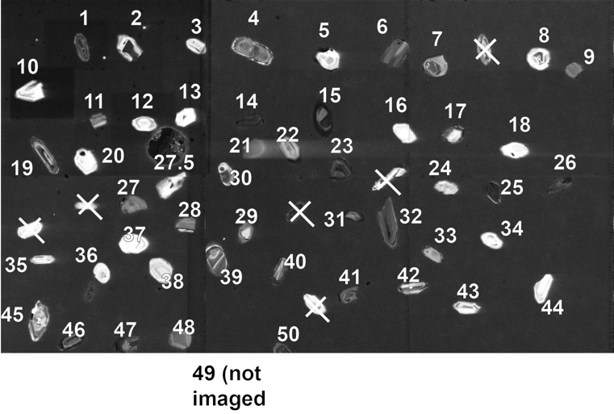

UR-EAC-04 sample zircons analyzed under cathodoluminescence.

References
Condon D.J., Schoene B., McLean N.M., Bowring S.A., Parrish R, 2015, Metrology and traceability of U-Pb isotope dilution geochronology (EARTHTIME Tracer Calibration Part I): Geochimica et Cosmochimica Acta 164: 464-480.
Crowley, J.L., Schoene, B., Bowring, S.A., 2007, U-Pb dating of zircon in the Bishop Tuff at the millennial scale: Geology 35: 1123-1126.
Gerstenberger, H., Haase, G., 1997, A highly effective emitter substance for mass spectrometric Pb isotope ratio determinations: Chemical Geology 136: 309-312.
Hiess, J., Condon, D.J., McLean, N., Noble, S. R., 2012, 238U/235U systematics in terrestrial uranium-bearing minerals: Science 335: 1610-1614.
Jaffey, A.H., Flynn, K.F., Glendenin, L.E., Bentley, W.C., Essling, A.M., 1971, Precision measurements of half-lives and specific activities of ²³⁵U and ²³⁸U: Physical Review C, 4: 1889-1906.
Krogh, T.E., 1973, A low contamination method for hydrothermal decomposition of zircon and extraction of U and Pb for isotopic age determination: Geochimica et Cosmochimica Acta 37: 485-494.
Ludwig, K.R., 2003, User’s Manual for Isoplot 3.00. Berkeley Geochronology Center: Berkeley, CA, 70 p.
Mattinson, J.M., 2005, Zircon U-Pb chemical abrasion ("CA-TIMS") method: combined annealing and multi-step partial dissolution analysis for improved precision and accuracy of zircon ages: Chemical Geology 220:47-66.
Schmitz, M.D., Schoene, B., 2007, Derivation of isotope ratios, errors and error correlations for U-Pb geochronology using ²⁰⁵Pb-²³⁵U-(²³³U)-spiked isotope dilution thermal ionization mass spectrometric data: Geochemistry, Geophysics, Geosystems (G³) 8, Q08006, doi:10.1029/2006GC001492.

